

Auto gallery

PROJECT



17700594

Amirhossein rahnama

Brief Information

Auto gallery is web site intended to help and guide everyone want to get a car or know some information about the cars in this site they will learn about prices , information and how the car look like also they can login and leave us a feedback.

Who is this site for?

This site is actually for anyone that want to know which type of which brand exists and if they want to get it with filling desire form and cart, they purchase the products.

What is the purpose of this site?

Actually there is only one purpose of this site and that’s to show how they can get information easily about the cars for buying it.

Pages: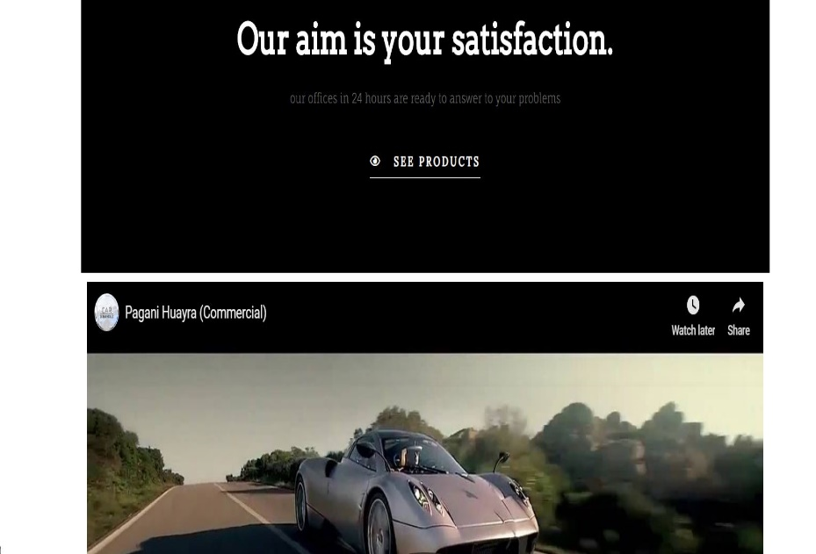

Home page🡪

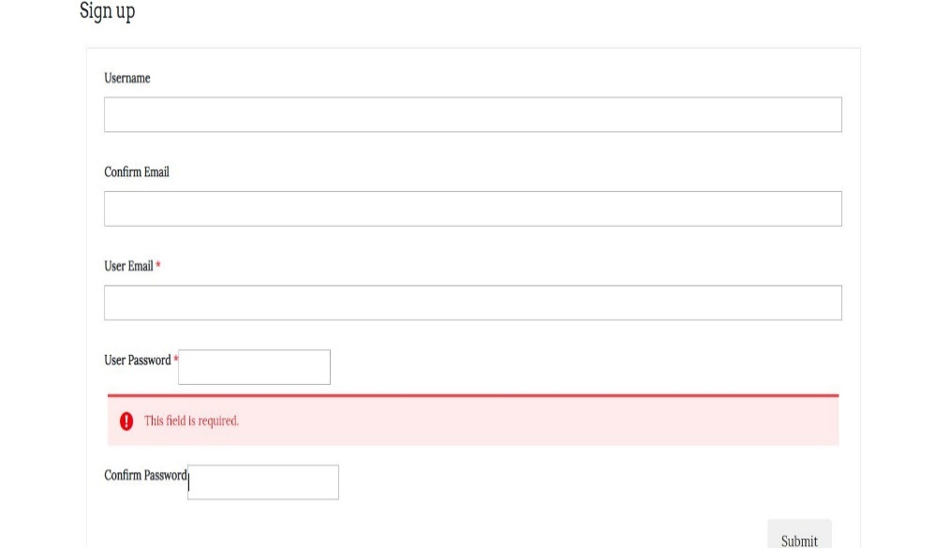Registration🡪

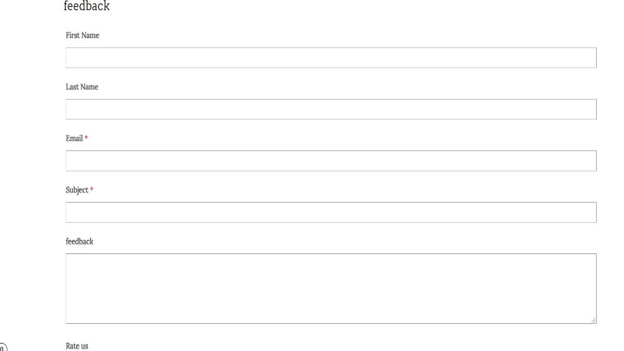Feedback🡪

BMW🡪

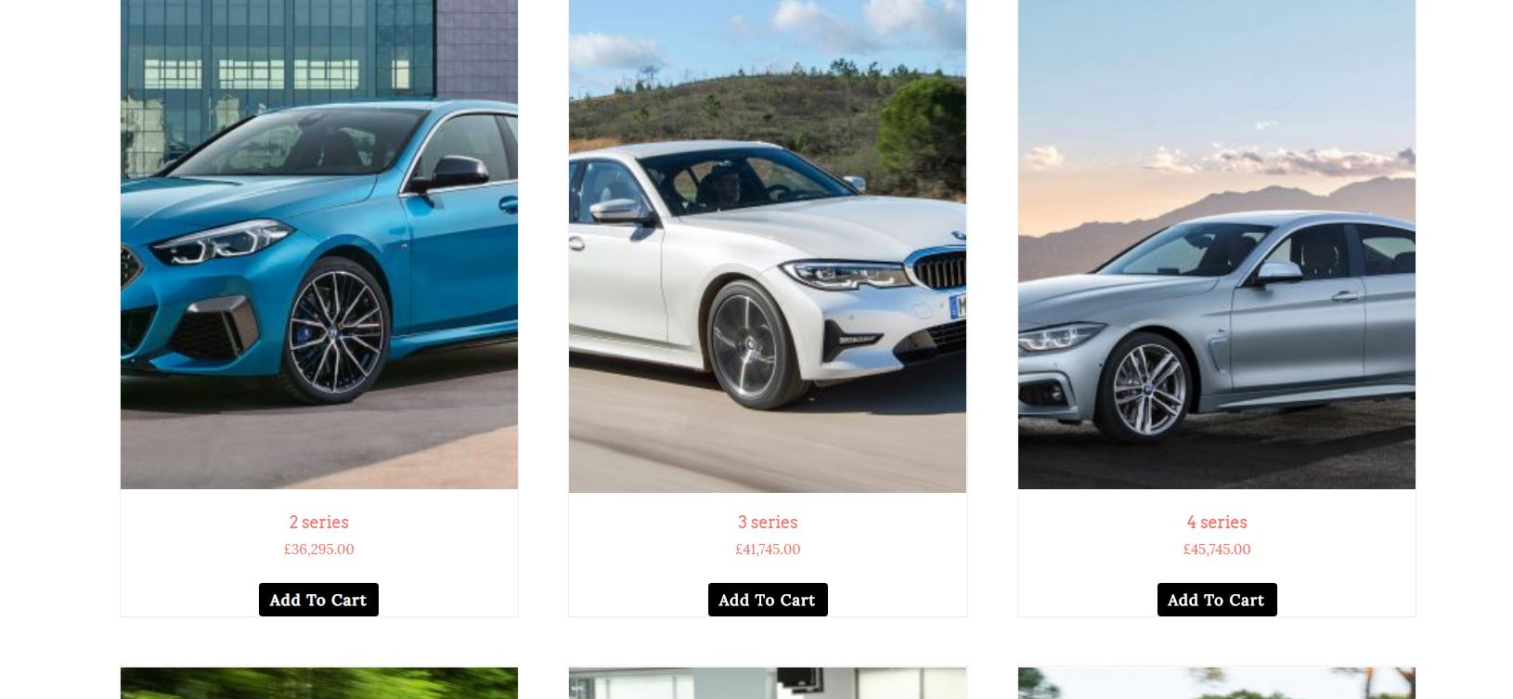

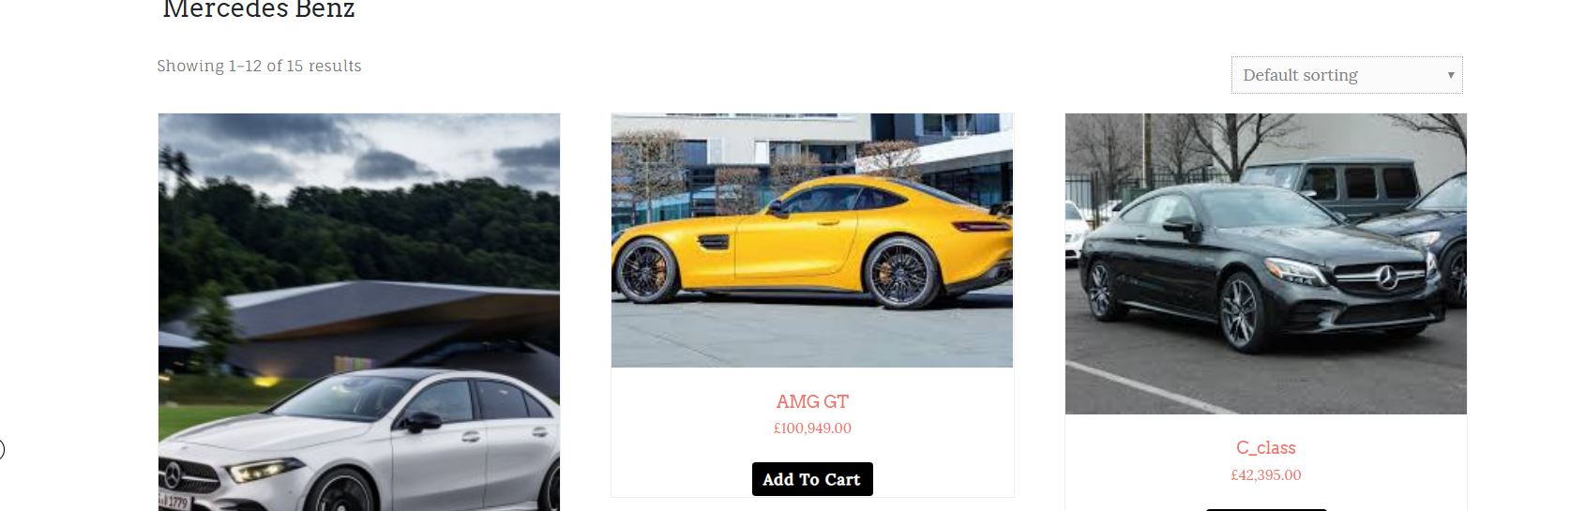Mercedes benz🡪

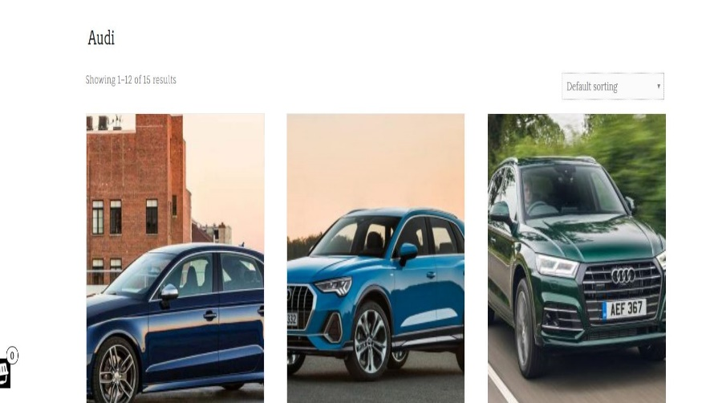Audi🡪

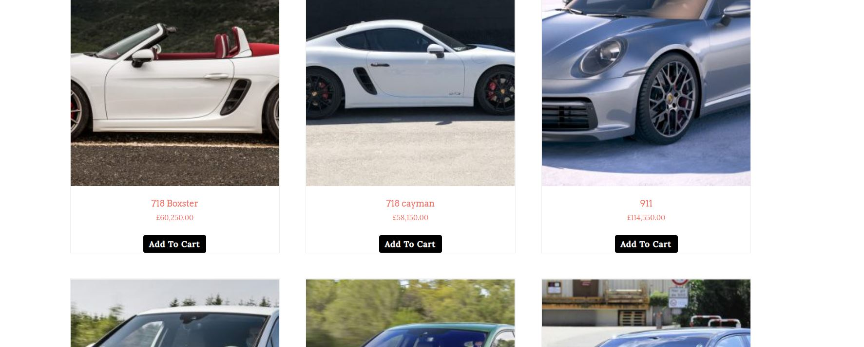Porsche🡪

|  |  |
| --- | --- |
| **Theme name** | link |
| Di ecommerce | <https://wordpress.org/themes/di-ecommerce/> |

|  |  |
| --- | --- |
| Host name | link |
| Cars world | <http://richmondhilleyecentre.ca/> |

References:

* Wikipedia
* Wordpress
* youtube

|  |  |  |
| --- | --- | --- |
| Name | category | purpose |
| sucuri | Security | The plugin was used for security purposes such as Auditing and logging files. |
| duplicate | Moving Site Online | The plugin was used to move the site from my local computer to the liveserver. |
| elementor | Page Editor | The plugin was used in UI purposes. |
| Yoast seo | Search engine | When it comes to on-page search engine optimization, few plugins can shine a candle to the efficacy and functionality of Yoast SEO. |
| **YITH WooCommerce Quick View** | image | Add a button in product loop to open a modal window with the product summary using ajax |
| **WPForms** | form | The plugin was used to create forms within the contact and registration/login pages |
| **WP Rollback** | rollback | Quickly and easily rollback any theme or plugin from WordPress.org to any previous (or newer) version without any of the manual fuss |
| **WooCommerce** | bussines | Whether you’re launching a business, taking an existing brick and mortar store online, or designing sites for clients you can get started quickly and build exactly the store you want. |
| **Akismet Anti-Spam** | security | Akismet checks your comments and contact form submissions against our global database of spam to prevent your site from publishing malicious content |
| **Max Mega Menu** | menu | Max Mega Menu will automatically convert your existing menu or menus into a mega menu. |
| **Everest Forms** | form | provides you with an easy way to create any kind of forms including contact forms. |
| **User Registration** | registration | create frontend user registration form and login form |
| **WooCommerce PDF Invoices & Packing Slips** | text | This WooCommerce extension automatically adds a PDF invoice to the order confirmation emails sent out to your customers |
| **Di Themes Demo Site Importer** | importer | Di Themes Demo Site Importer plugin can be use to import demo website developed by Di Themes. |